6-6-2026
Portfolio Deep Learning
Max ter Steege

Inhoudsopgave
Portfolio assignment – College 1 – NN 2
Portfolio assignment – College 2 – CNN 6
Portfolio assignment – College 3 – RNN 9
Portfolio assignment – College 4 – Hypertuning 12
Portfolio assignment - Ethics part one 15
Portfolio assignment – Ethics part two 17
References 19

Portfolio assignment – College 1 – NN
Before experimenting with the hyperparameters, I have taken a screenshot of the base run with the standard parameters from the example script. See screenshot below.
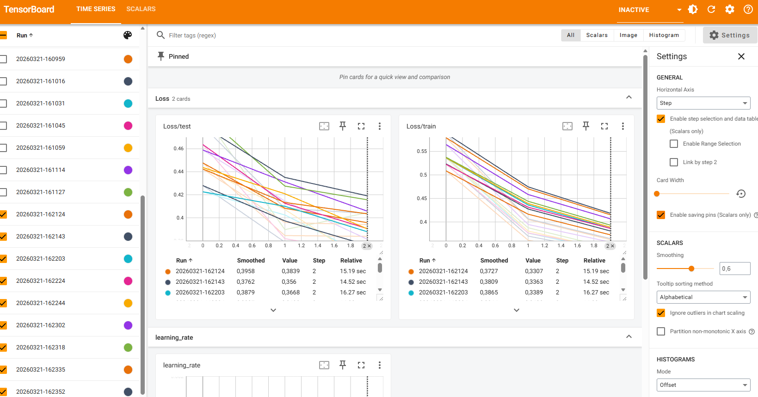
There are 9 runs visible, all with a steady decline in training loss. The decline in test loss is varying a bit more, although all of them seem to be sloping downwards, hence indicating improvement in all of the runs. In the baseline experiment, the smoothed version of the following runs was the best (both for training and test):
The 162143 run has the following connected model settings:
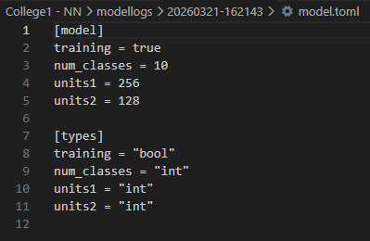
And the 162124 run has the following:
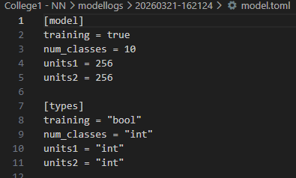

My hypothesis is as follows:
I expect the training and test loss to improve when I increase the amount of epochs and increase the amount of units. I will not increase the amount of layers (yet) since I don’t want to risk overfitting. I think a lot of improvement is already possible through increasing the epochs and the unit size. Also, especially since both training and test loss lines are declining, it looks like the model is still busy learning. So I will start with increasing only the epochs to evaluate the influence.
In my first test, I increased the amount of epochs to 9. The training obviously took longer due to increasing the epochs, but the results also increased a lot. What is mainly interesting to see is that my lines are becoming more flat, so it looks like increasing the epochs took care of the fact that the model was not done with its steep learning yet. That’s resolved now!
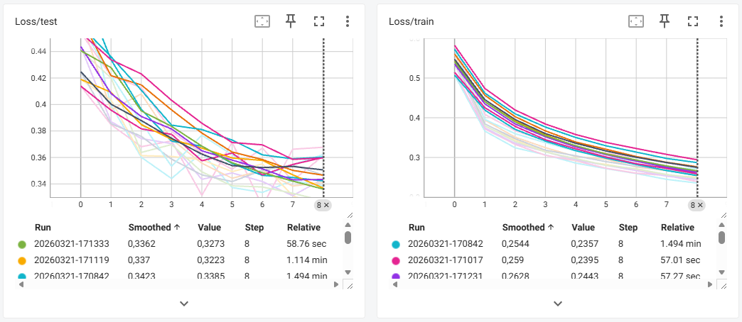
For the final experiment, I will increase the amount of units and keep the amount of epochs at 9. Again, training took way longer due to adding 1024 in units. It actually took so long that I decided to remove 64 and 128 and keep it at 256 and 1024 (since 256 seemed to be better than the other units in previous runs). So I kept epochs at 9 and added 1024 to increase model performance and deleted the other units to improve training time a bit. The screenshot below shows that training and test loss both improved when compared to previous run.
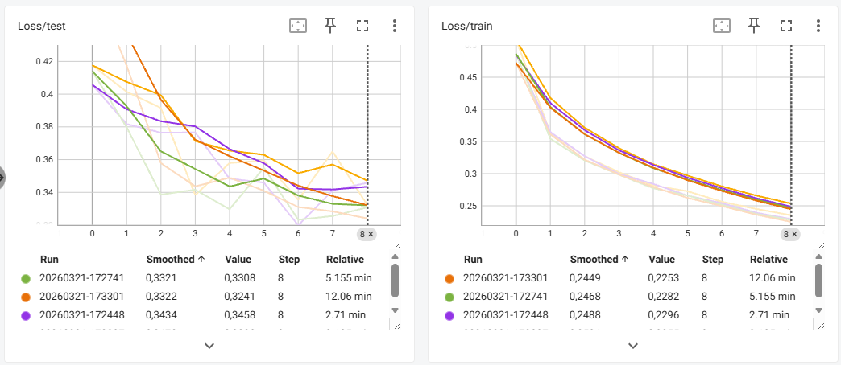
For comparison, I have added below the graphs of the training and test loss of the best models of each adjustment including the baseline, so that it’s clearly visible how changing the parameters helped improve model performance.
First, the training loss. The training loss seems to improve with every iteration change. Although the last iteration change is probably not worth it. Training time went up by almost a factor of 12 while training loss only slightly improved.
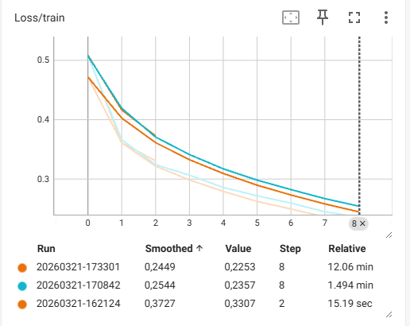
Lastly, the test loss. Although the test loss improved, the change in model performance is relatively low compared to the extra time it took to train the model. From this perspective, its probably not worth it to train the model 5 times longer for such a small improvement. A potential gain is better found in tuning other parameters (but of course this depends on the context of the situation at hand).
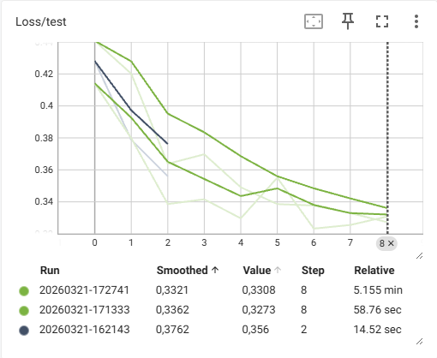

Portfolio assignment – College 2 – CNN
Since I will be applying some more changes in my model, I will start with a baseline run that is a bit faster than my last script. So I adjusted units to 256 and 512 and amount of epochs to 4.
Baseline run:
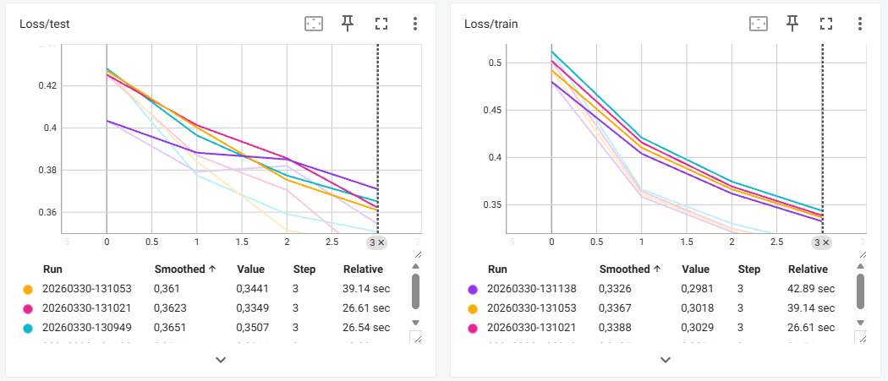
I will start with a hypothesis again.
After adding dropout, normalization, extra convolution layer and extra pooling layer, I expect the training loss and test loss to decrease, while I expect the metric value to improve. At the very least, I expect the generalization of the model to improve (especially after adding dropout).
My next run included dropout added of 0.1 after 2 layers. Results actually have gotten a bit worse, but I can imagine this happening since we are leaving out more information, hence the model will have a bit of a harder time to capture certain patterns (especially since I lowered the amount of epochs).
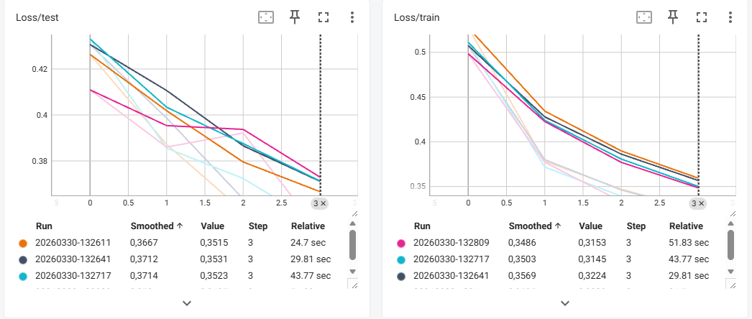
After including dropout, I added normalization and compared the results again. While still including dropout. So now we can see the results are actually improving beyond the baseline run.
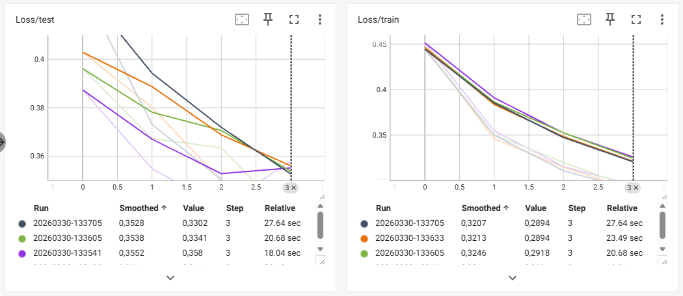
Now, convolutional and pooling added, which delivered an incredible improvement on both the training and test loss.
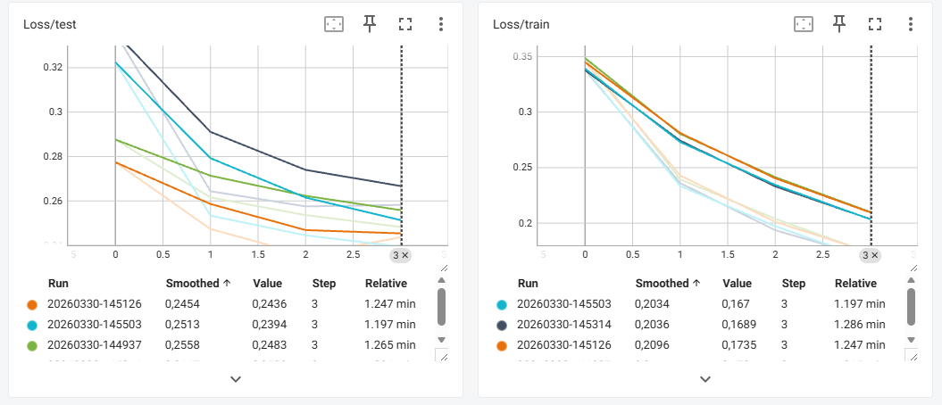
I did all of this using Tensor Board, but now I also added logic to log via MLFLOW and reran the latest run (including convolutional and pooling), so I can show that logging works via MLFLOW.
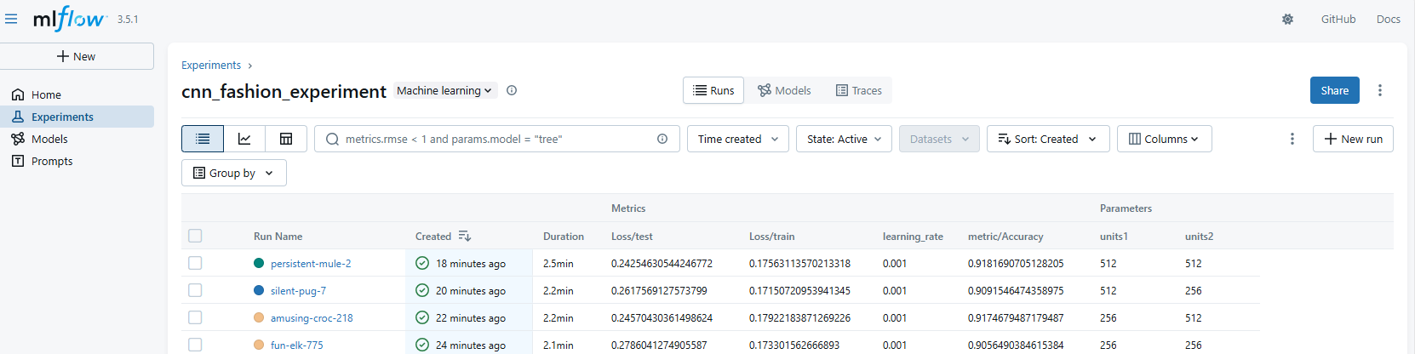
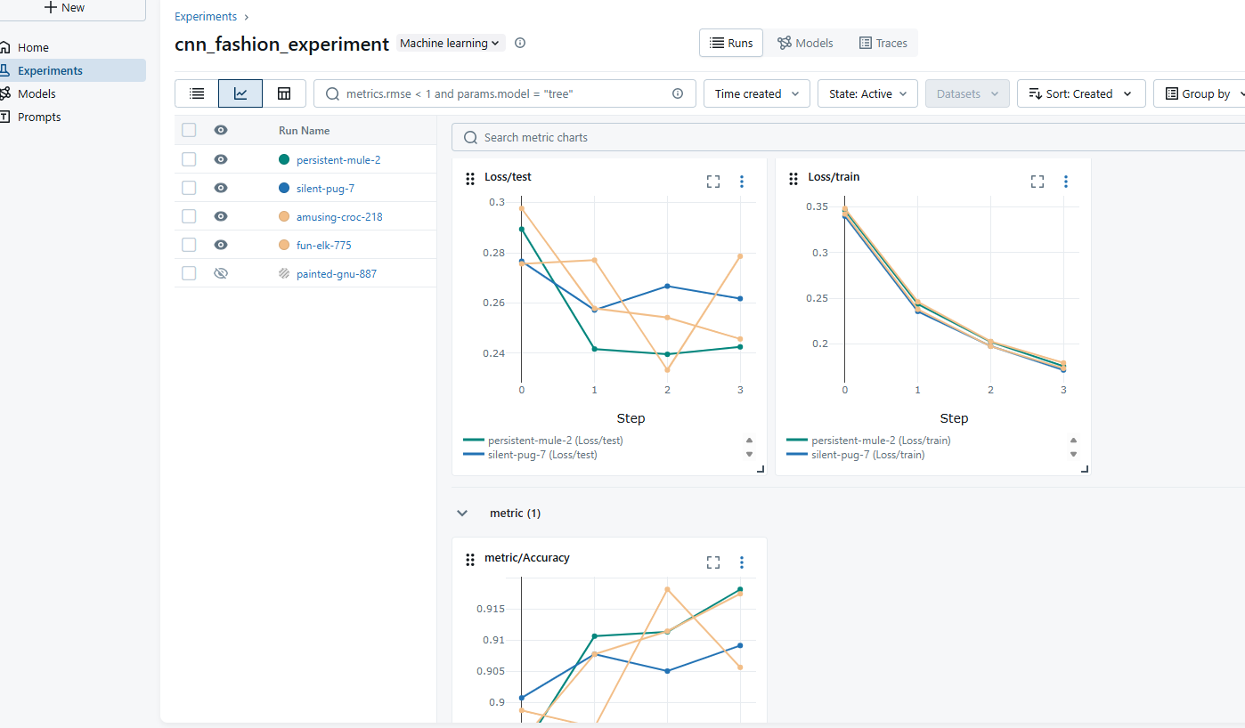

Portfolio assignment – College 3 – RNN
Same principle as previous portfolio exercises.
First, I start with the baseline run:
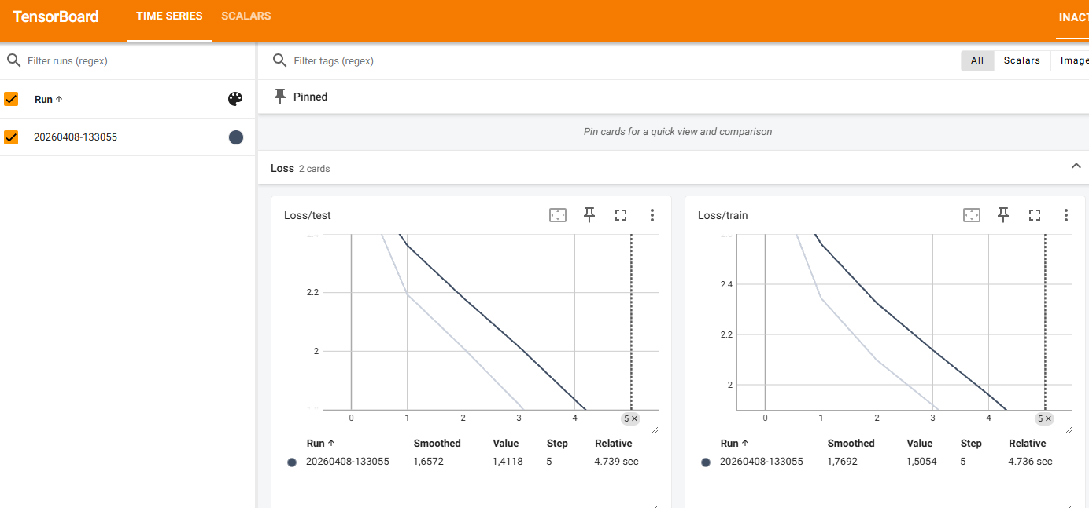
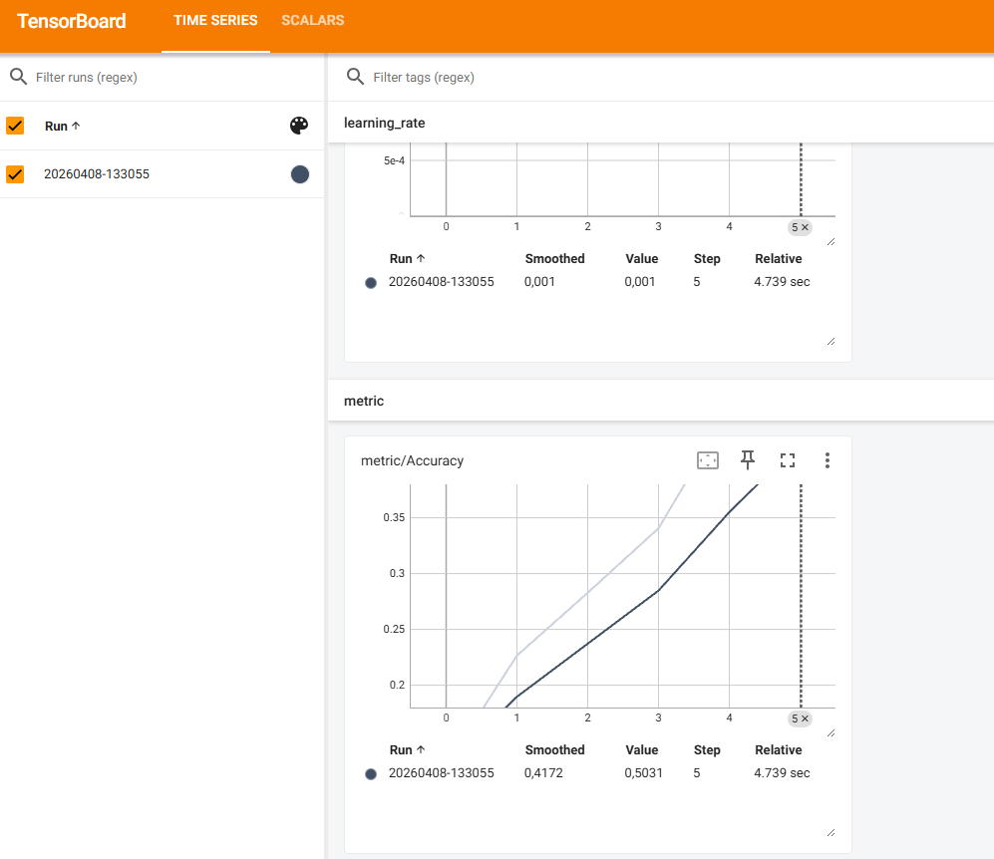
For the second iteration, I decided to tweak the parameters of the GRU model
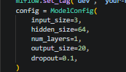 original parameters
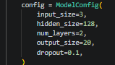adjusted parameters
This resulted in longer training, but also in….:
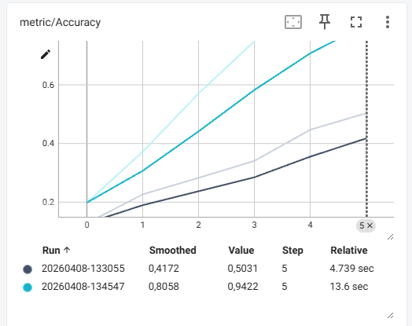
A way better accuracy score!
Next I increased hidden size even more and also dropout a bit to prevent overfitting.
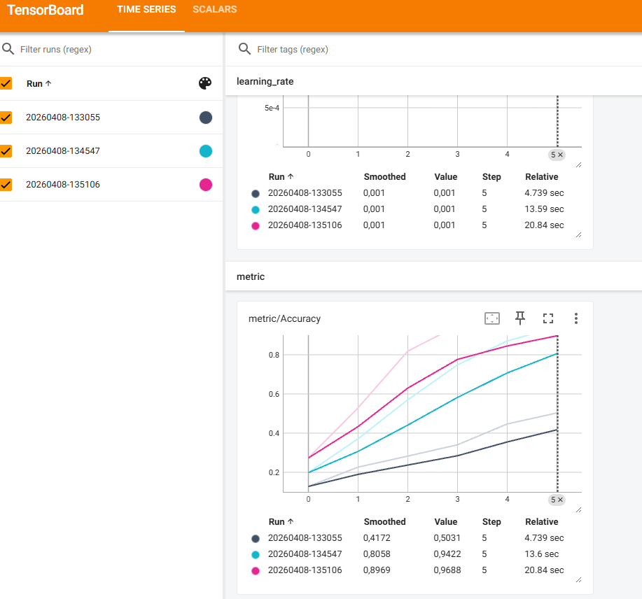
This last run achieved an accuracy well above the mentioned goal in the script, so it seems like mission successful.

Portfolio assignment – College 4 – Hypertuning
I wanted to challenge myself with a new dataset, so I chose the CIFAR(10) dataset. I’ve also added the script in my Github, so you can see how I apply my logic throughout the script. I started off by implementing a simple baseline model to ensure proper training, tuning and logging. Baseline model has poor accuracy (as would be expected), 0.3594* after 5 epochs. (*Note added later: I noticed in my later runs that my outcomes were not deterministic, so I implemented a fixed seed to ensure proper testing from there on out. This is why the value of the screenshot is different from my table below)
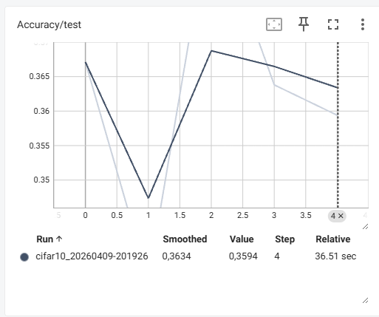
My hypothesis is: Increasing the complexity of my model will improve classification accuracy on CIFAR-10, up to a point where performance flips due to overfitting.
I’ve done various improvements, I’ve added a table below that shows the results per improvement.
Model | Improvement | Accuracy | Comments
Baseline | None, baseline model. | 0.3829 | Epochs = 5
Improved_v1 | Conv2d model | 0.3966 | Still linear
Improved_v2 | Conv2d non linear | 0.5587 | Added ReLU
Improved_v3 | Raised hidden units to 32 (doubled) | 0.5969
Improved_v4 | Added a layer | 0.6297 | Learning curve still steep, so will increase epochs
Improved_v5 | Increased epochs to 10 | 0.6049 | Accuracy actually decreased, I will add pooling now
Improved_v6 | Added pooling | 0.6675 | Epochs to 5 again for a bit faster training
Improved_v7 | Epochs to 10 again to see if it helps… | 0.6823
Improved_v8 | Added dropout | 0.6525
Improved_v9 | Added another layer | 0.6998
Improved_v10 | Added BatchNorm | 0.6289 | Steady increase until last epoch, then a massive dip from 0.7085 to 0.6289. Overall over the epochs, accuracy improved so improvement seem to have been useful. I will continue training for now with different improvements but will keep this in mind.
Improved_v11 | Increased amount of channels | 0.7743 | Training seems stable now.
Improved_v12 | Adding classifier head (before final classification) | 0.7785 | One run had 0.7924
Improved_v13 | Added random horizontal flip to training | 0.7745
Improved_v14 | Added random crop | 0.7745 | Other epochs had different accuracy, so seems like a coincidence that accuracy is the same
Improved_v15 | Increased epochs to 20 | 0.7731 | But training loss improved nice and steady. Model seems to be quite stable at this point.

The readme shows that there was a 18% test error. My model reached 77.31% accuracy, which I think comes close already to the mentioned test error with optimal hyperparameter tuning. Below I’ve added the curves of training as visualized via TensorBoard.
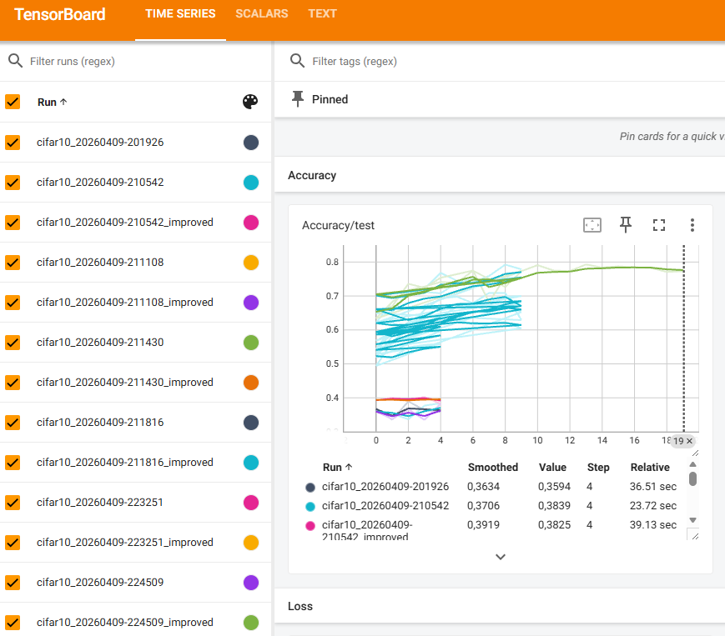
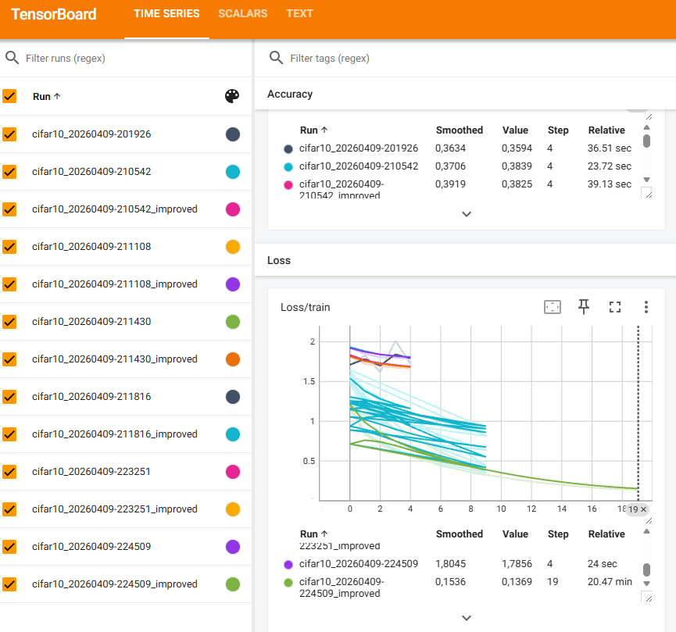

Portfolio assignment - Ethics part one
Evaluating ethical models & application on data ethics
Various ethical approaches provide a framework to resolve moral dilemmas, such as a ‘Deontology’ approach (Misselbrook, 2013). The deontology approach is mainly influenced by Immanual Kant and evaluates actions based on how they apply to universal actions, duties and principles, independent of the outcome. In other words, an action is ethical if it is morally correct. Virtue ethics offers a different approach. Mainly influenced by Aristotle, the focus lies on character and being a virtuous person (Van Hooft, 2014). The main thought behind being a virtuous person according to Aristotle, is to achieve ‘Eudaimonia’ which refers to the ultimate goal; to achieve human flourishing (Huta, 2013). An action is evaluated based on topics like integrity, responsibility, fairness and how it contributes to achieving eudaimonia. Therefore, an action is ethical if it is virtuous and contributes to achieving the ultimate goal.
On a finer granularity, ethical models provide a framework on how to handle moral cases, such as Impact Assessment Mensenrechten en Algoritmes (IAMA) and Koninklijke Nederlandsche Maatschappij tot bevordering der Geneeskunst (KNMG).
The IAMA framework (Ministerie van Binnenlandse Zaken en Koninkrijksrelaties, 2021) focuses on assessing the human rights impact of algorithmic systems before and during deployment. It evaluates aspects such as discrimination, transparency, and potential societal harms. The purpose of IAMA is to identify risks as early as possible and ensure that the developed algorithmic systems respect fundamental rights. An action is considered ethical when the algorithmic system can be justified in terms of human rights, transparency, and responsible governance.
The KNMG (KNMG, n.d.) ethical framework approaches moral dilemmas from a medical decision making perspective. The model outlines six clear steps on how to handle moral cases. The emphasis lies on careful moral reflection rather than on a purely technical risk assessment. The KNMG approach encourages users to examine a case from multiple perspectives, weigh conflicting values, and reach a justified ethical decision.
Both models provide a framework on how to handle a moral dilemma, but differ in their application and in their field of practice. The IAMA framework is a bit more bureaucratic (as it finds it origin in the government), while the KNMG model can be seen as a more practical approach (as it finds it origin in the medical field).
Suppose a hospital considers implementing an algorithm that predicts the remaining life expectancy of patients. Using the IAMA framework, the primary focus would be on evaluating risks such as bias in the training data, transparency of the model, possible discrimination, and the impact on fundamental rights. The goal would be to determine whether the algorithm can be deployed responsibly and which safeguards are required (all in all quite bureaucratic without a real consideration for ethical implications).
Using the KNMG framework, the focus would lie more on the ethical implications, such as whether communicating model predictions to patients would be worth it (which is a practice that follows the main thought of virtue ethics). Medical professionals would have a discussion about questions such as whether providing this information benefits the patient, whether it could cause harm, and how it affects patient dignity.
The outcome of both approaches could lead to similar conclusions, but the reasoning behind the decision differs. In my view, while any situation is highly context dependent, the KNMG ethical approach is generally more useful for data ethics dilemmas. Ethical situations are often highly context dependent, and rule based approaches do not always capture the complexity of real world situations. This does not mean that frameworks such as IAMA (in a sense a deontology approach) are useless, but that the application of these frameworks is context dependent as well. For example, IAMA could be more useful for identifying specific detailed risks in vast algorithmic systems. Ultimately, ethical decision making more often benefits from combining a structured framework with context dependent moral issues in data ethics cases and therefore I prefer the KNMG approach.

Portfolio assignment – Ethics part two
A Dutch dating app needs to adjust their algorithm to prevent discrimination. It was decided that the developers need to adjust their algorithm to make sure that non-Dutch users are being shown or matched as much as Dutch users (College voor de Rechten van de Mens, 2023).
My first impression is that the issue likely comes from the training data. Dating algorithms usually learn from past user behavior. If users historically liked or matched more often with certain groups, the model will learn that pattern. Lower visibility for non-Dutch users does not automatically mean the algorithm was designed to discriminate. It probably just means that the training data contained fewer samples of non-Dutch matches. Also, fewer matches with non-Dutch users can also be linked to user preferences of Dutch users such as profile quality, hobbies, language, or attractiveness. At the same time, there is a difference between individual preferences and fairness on a group level. For example, filtering by gender in a heterosexual dating app is functional, not discriminatory.
I doubt that forcing equal visibility is the best solution. It changes the results of the model instead of improving the model itself, and this may lower its performance. A better approach would be to first check whether certain groups are actually under represented for unfair reasons. This can be done by analyzing the data and letting humans review the results (semi supervised learning). If a real bias is found, specific adjustments can be made, instead of forcing full ‘equality’ for everyone (which may lower actual match percentages).
Figure 1
DAG – Dilemma algorithm dating app
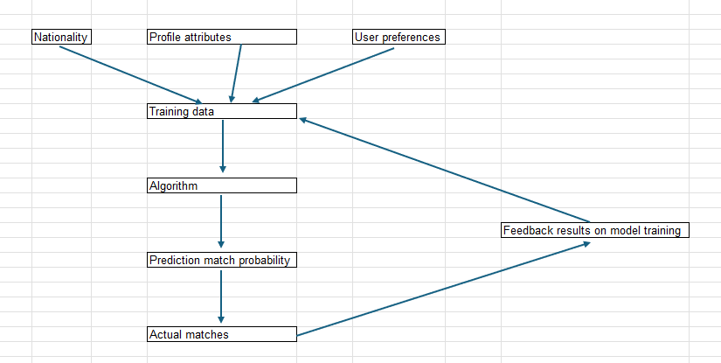
I don’t see any direct difference with the first impression after drawing the DAG.
If a data scientist gets an assignment like this, the first step should be to understand how the system actually works before changing anything. There needs to be a check whether the problem is caused by the model itself or by actual user behavior/preferences. Then measure whether there is real unfairness in visibility or matching rates. If action is needed, choose a clear fairness goal and apply targeted adjustments instead of forcing equal results without analysis. Finally, document the tradeoff between fairness and model performance.

References
College voor de Rechten van de Mens. (2023, 09 6). Dating-app Breeze mag (en moet) algoritme aanpassen om discriminatie te voorkomen. Opgehaald van mensenrechten: https://www.mensenrechten.nl/actueel/nieuws/2023/09/06/dating-app-breeze-mag-en-moet-algoritme-aanpassen-om-discriminatie-te-voorkomen
Huta, V. (2013). Eudaimonia. In Oxford handbook of happiness (pp. 201-213). Oxford University Press.
KNMG. (n.d.). Ethische toolkit. Opgehaald van KNMG: https://www.knmg.nl/ik-ben-geneeskundestudent-1/ethische-toolkit/zelf-aan-de-slag
Ministerie van Binnenlandse Zaken en Koninkrijksrelaties. (2021). Impact Assessment Mensenrechten en Algoritmes (IAMA). Opgehaald van https://www.uu.nl/sites/default/files/Rebo-IAMA.pdf
Misselbrook, D. (2013, 4). Duty, Kant, and deontology. British Journal of General Practice, 63(609), p. 211. Opgehaald van https://pmc.ncbi.nlm.nih.gov/articles/PMC3609464/
Van Hooft, S. (2014). Understanding virtue ethics. Routledge.

